INSERT INTO LOCATION (LOCNO, FACNO, LOCNAME) VALUES (‘L107’,’F104’,’DOOR’);
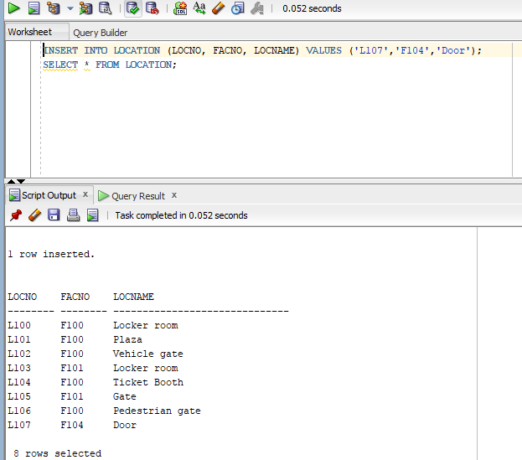
SELECT * FROM LOCATION;

